Documentation of WRO Future Engineer 2023

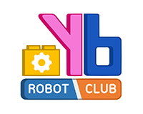

By Sunflower

This document contain:
- Team member and the vehicle
- Engineering information
  - Mobility management
  - Power and Sense Management
  - Obstacle management
  - Engineer factors
- GitHub Link
- YouTube Link

Abstract
Sunflower is a team of three who studying at Yothinburana School. We are normal student who study every weekday and work on the robot at Yothinburana Robot Club after school. It took us four months to complete it. It cost approximately 217 USD (8000 THB).
The robot uses a Lego part as a fame and bolts to attach the controller, camera, and other components.

Since this is the second year of the competition, the robot must be different from the first. Our senior attended the international last year in Dortmund, therefore we used an example from that year and modified it. Since the Arduino UNO board is difficult to operate, we first purchase a motor and sensor shield. However, the fact that we must disconnect the compass RX and TX wires each time we upload a software and solder the wires for the Arduino makes it vulnerable to break.
We go for the POP-32 board this time. POP-32 is a 32-bit controller that makes use of a 32-bit STM32F103CBT6 microcontroller to enhance capabilities like reaction time and multitasking. Additionally, it contains an RX TX port and a JST3AA-8 port for use with color, touch, or servo sensors. Additionally, it has an OLED screen that can show whatever program we choose.
1. Team member and the vehicle
Team members and photos

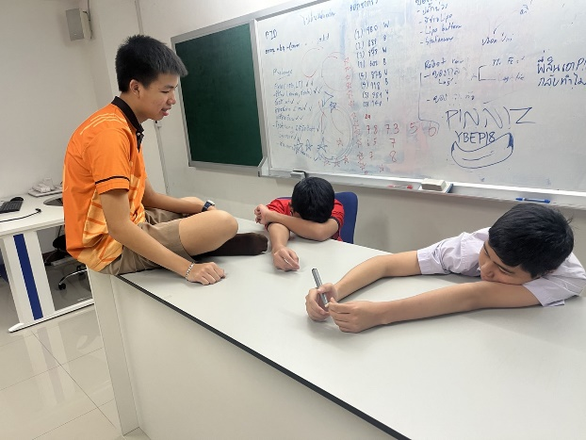
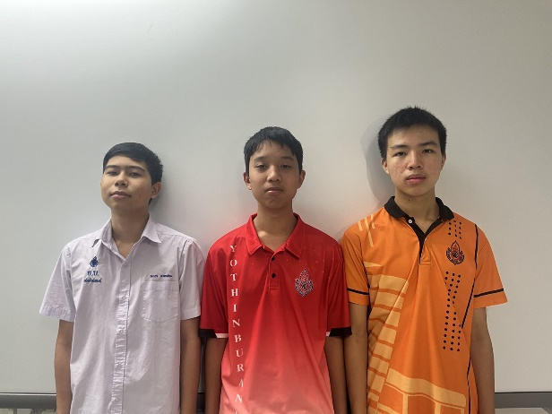

We are Team Sunflower from Thailand. Currently, we are studying at Yothinburana School. We expected to do our best on the international stage. We were the champions in Thailand, but that was just the first step of our journey to the international stage. We want to be in the top 5 of this tournament. To prove that Thailand is not bad at robotics, to show the world what we are capable of.
White shirt is Mr. Vorawet Narkglom, our team's main programmer. At 15 years old, he's a talented Grade 10 student in the Yothinburana School English Program. With his coding skills, he plays a crucial role in bringing our robot to life.
Red shirt is Mr. Vichaiwat Koonsap, our document designer. Also 15 years old, Vichaiwat is a Grade 10 student in the Yothinburana School Regular Program. He's responsible for creating clear and informative documentation about our robot.
Orange shirt is Mr. Sakolnat Raktaengan, our robot designer. At 15 years old, he's a Grade 10 student in the Yothinburana School English Program. Sakolnat's creative and technical expertise is instrumental in crafting the physical design of our robot.

Vehicle Photos
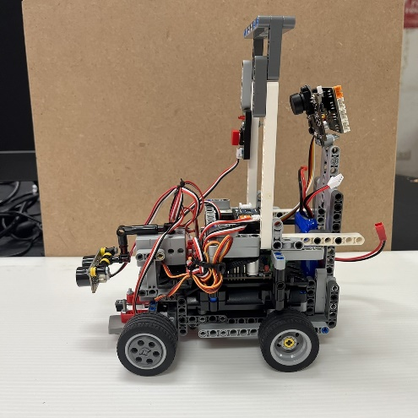
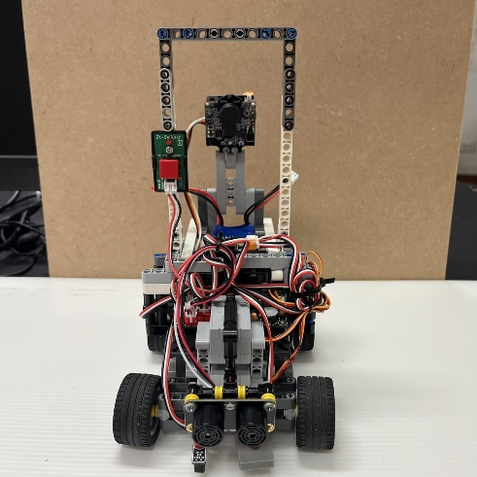

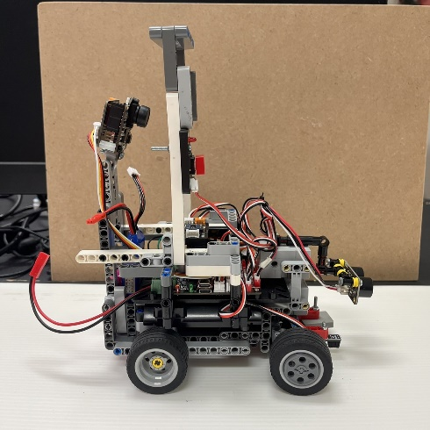
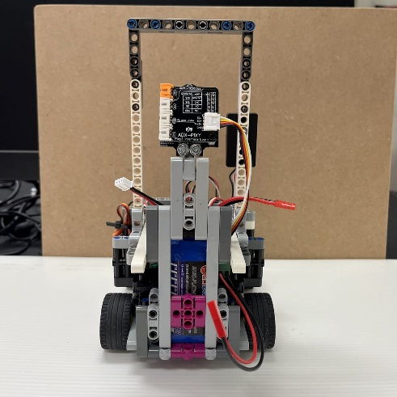

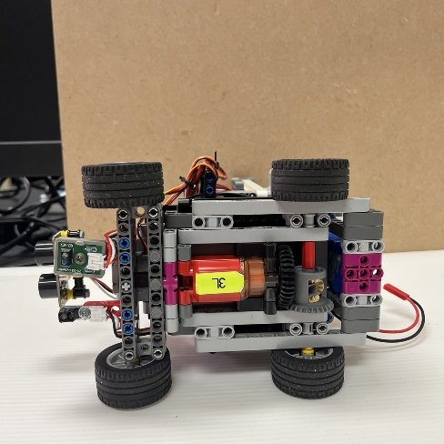
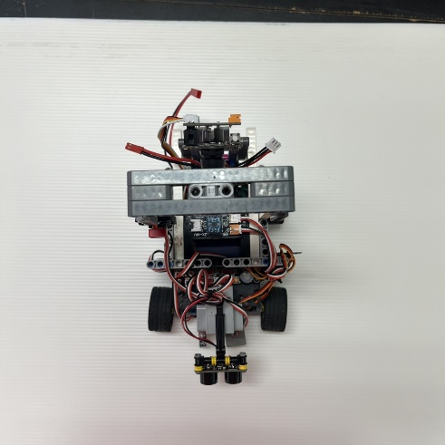

2.Engineering information
2.1 Mobility management
- Power Function Large-motor by LEGO
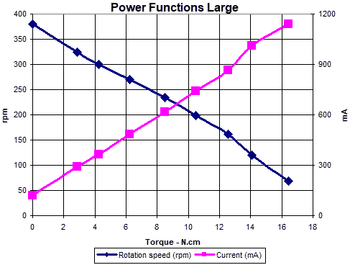
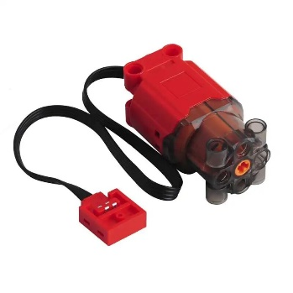
We chose this motor for driving motor. A high-speed, user-friendly motor that requires only a quick soldering of wires for effortless setup. We opted for this motor among various options due to its balanced performance – neither excessively fast nor overly slow. Its seamless attachment to the robot frame makes it an ideal choice, and it offers versatility for compatibility with both Lego and Arduino systems through soldering adjustments.
Technical Information
-Speed : 390 rpm
-Maximum torque : 40 N/cm
-Voltage : 9 v
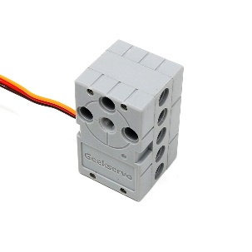
- GEEKSERVO 2kg 360 Degrees
This servo is for steering and ultrasonic rotation. We carefully selected this servo for our robot because of its exceptional ease of attachment to our robot frame, as well as its precise 180-degree steering capacity. This servo's compatibility perfectly aligns with our design requirements and ensures optimal performance.

Technical information
-Rotation: 360 Degree
-Start Voltage: 2.5V
-Working Voltage: 3.3-6.0V
-Rated Voltage: 4.8V
-Rated Current: 70mA
-Maximum torque: 1.6 0.2 kg-cm (4.8V)
-Angle rotation speed: 60 / 0.14s
  - Power and Sense Management
- PIXY version 2.1
The camera is an integral component within our robot, providing the capability to identify color blocks effectively. It plays a pivotal role in our robot's functionality by swiftly detecting these color blocks and efficiently transmitting corresponding signals. This seamless process empowers our robot to make rapid, real-time decisions, ultimately enhancing its navigation capabilities and ensuring optimal performance in various scenarios.
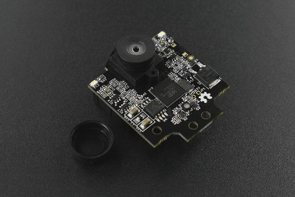
Software and Library: https://pixycam.com/downloads-pixy2/

Technical information
-Resolution : 1296 x 976
-Processor: NXP LPC4330
-Cloak speed : 204 MHz
-Ram : 264KB
-Flash : 2 MB
-Framerate : 60 fps
-Connection : USB, UART, SPI, I²C

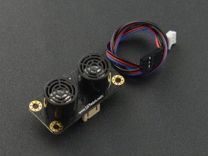
- Gravity URM 09
The ultrasonic sensor plays a vital role in guiding the robot's navigation by accurately detecting distances between the robot and potential obstacles. Its precision in measuring distances ensures that the robot can maneuver and make informed decisions to navigate its path safely and effectively, avoiding collisions and maintaining its course.

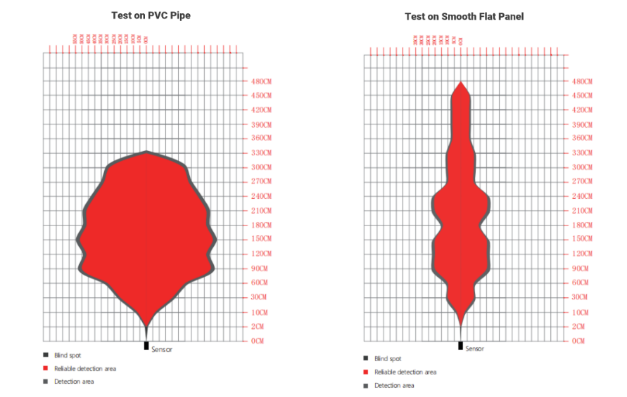
Technical information
-Supply Voltage: 3.3~5.5V DC
-Operating Current: 20mA
-Operating Temperature Range: -10℃～＋70℃
-Measurement Range: 2cm～500cm (can be set)
-Resolution: 1cm
-Accuracy: 1%
-Frequency: 50Hz Max

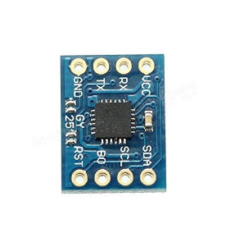
- GY-25
This is a compass for our robot. This component equips the robot with the ability to discern its current orientation, thereby enabling it to determine the appropriate direction for turning.

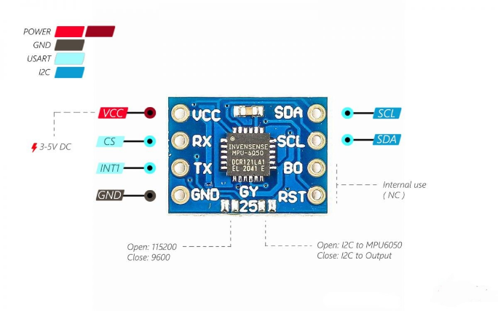
Technical information
-Chip: MPU-6050
-Power voltage: 3 - 5V
-Communication mode: Serial communication ( baud 9600,115200 ), IIC communication
-Model Size: 15.5mm*11.5mm
-Pitch: 2.54mm
-Direct Data: YAW ROLL PITCH
-Heading angle (YAW ): ± 180 °
-Roll angle (ROLL): ± 180 ° GY-25 Pinout
-Pitch angle (PITCH): ± 180 °

- Color sensors.
  - Virus III by Designed by Sopon 4.2 ZX-03 Reflector by INEX

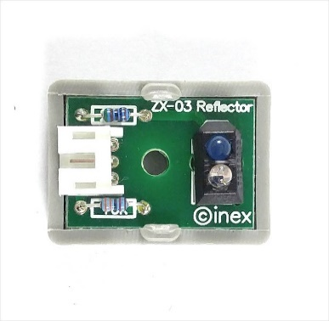
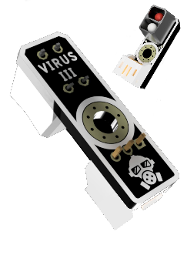

Red Sensor Blue Sensor

We use the color sensor to check the line color which is red and blue. While the blue line is checked using the red sensor, the red is checked using the blue. Both Light Reflector sensors are used to measure the reflected light and in the race field we use it to check the line when the robot turned. After the robot notice what the color is, it will know how many times it have orbit around the race field, making it smarter and better equipped for the race.

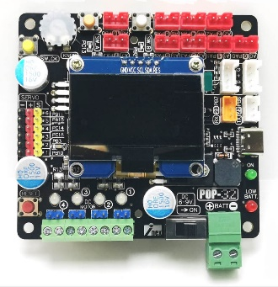
- POP-32i
This is our controller, the brain of our robot. Sporting a potent 32-bit architecture, it increases the reaction times, enhances precision, and improves multitasking capabilities, and more. Additionally, it boasts a generous array of 9 input/output ports (0-8).

Technical information
- Microcontroller: Uses a 32-bit STM32F103CBT6 microcontroller with 128KB of flash memory for new programs, which can be programmed up to 10,000 times. It has 20KB of RAM.
- Clock Signal: The clock signal is 20MHz from a ceramic resonator.
- JST 3-Pin Ports: It has JST 3-pin connectors with 11 points for connecting sensors and peripheral devices.
- LED Indicators: Includes LED indicators for power status, low battery alert, and USB port connection status.
- RESET Switch: Features a RESET switch.
- USB Port: Provides a USB port for program downloading and data communication with a computer.
- Power Input: Has a power input port via a screw terminal block that accepts power from 6V to 9V with an on/off switch for power control.
- Battery Compatibility: Designed for use with maximum 2-cell lithium polymer batteries (7.4V to a maximum of 8.4V).
- Voltage Regulation: Includes a voltage regulation circuit to supply 3.3V to the microcontroller, OLED display, and main input/output ports.
- Digital and Analog Ports: Offers 9 digital or analog input/output ports, including A0 to A8 (corresponding to PA0 to PA7 and PB0), for receiving external signals.
- I2C Ports: Provides 2 sets of digital ports supporting I2C bus (SDA and SCL) using PH4 connectors arranged in GROVE format.
- UART Port: Includes a UART port for sequential data communication, with one set of ports on PB7 (RxD) and PB6 (TxD).
- Motor Driver Circuit: Features a motor driver circuit with 4 channels and LED status indicators, supporting motors from 3V to 12V. It can continuously drive a current of 1.5A per channel, with a maximum of 2A per channel, and includes overcurrent protection.
- Servo Motor Ports: Offers 6 servo motor ports for driving servo motors.
- Speaker: Includes a piezo speaker for generating sound, connected to PB5.
- OLED Display: Features a 1.5-inch OLED display with a resolution of 128 x 64 pixels, capable of displaying graphics and text. It communicates via I2C.
- Push Buttons and Knob: Includes push buttons (OK, SW-A, SW-B) and an adjustable knob (KNOB) for input and testing.

- Helicox 7.4 voltage Li-po battery.
The power source for our robot. This battery is the Lithium Polymer type, normally we use at 8.3 and recharge at 7.2 to save the battery life and for safety
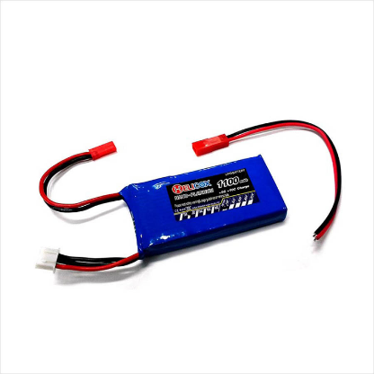
Technical information
-2 cells voltage: 7.4V
-Capacity: 1100mAh 30C
-Can be charged at a current of up to 5 times the capacity (5C)
-Connectors are in a JST type that can be easily disconnected

Wiring

2.3 Obstacle Management
2.3.1 Qualification round
In this round, we'll use the ultrasonic sensor to calculate the distance between the robot and the wall, making sure it remains in the safe and effective distance.

In this simulation, we will use the black square to represent the robot, and the large square to represent the wall. The robot will remain the safe distance with the wall.

The robot maintains a distance from the wall by using ultrasonic sensors for maintaining distance. The gyro sensor calculates the required steering adjustments to keep the robot moving in a straight line. This entire program is achieved with the help of a PID (Proportional Integral Derivative).

